***EQUIFAX***

CMS Fusion

**REFINEMENT**

**DOCUMENTATION**

Table of Contents

Refinement 2

1. Refinement Home 2

2. New Refinement Setup 3

3. Householding Key Configuration 4

4. Householding: Negative Household Drop 5

5. Household 6

Record Status 7

Record to Process 7

6. Customer Elimination Options 7

7. Suppression Options 9

8. Dedupe Options 10

9. Summary: Refinement 11

# 

# Refinement

Here we refine the population of data that we got after the first level criteria filtering and scoring process. We will be using the header table from data menu here. We use header because it contains the data for every consumer

## Refinement Home

All the refinement processes created for the current project are listed in the Refinement’s home screen.

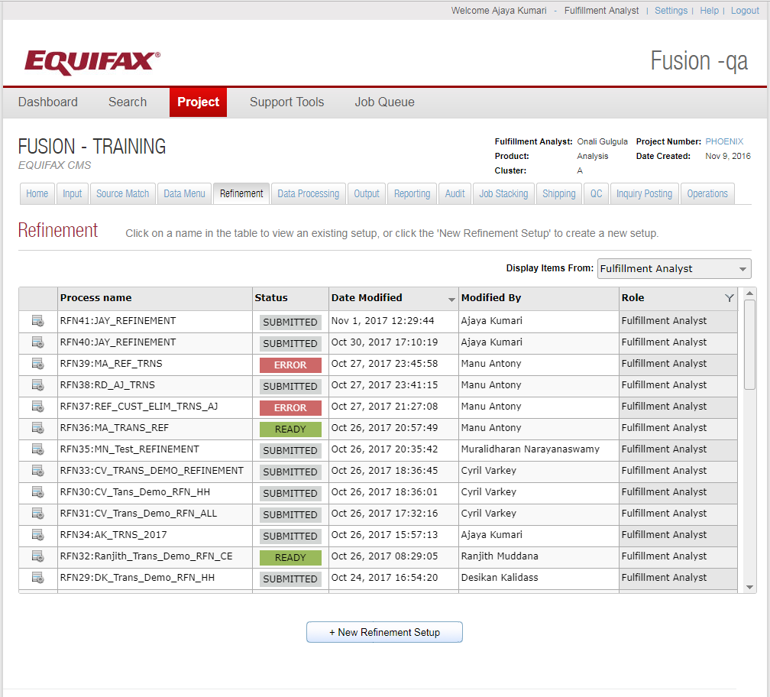

By clicking on the +**New Refinement Setup** button we can create a new Refinement process. All the Refinement processes are detailed in the Refinement grid. The main fields are Process name, Status, Date Modified, Modified By and Role. They are explained as follows:

* **Process Name**: All the Refinement process names are displayed in this column.
* **Status**: Refinement process has following valid statuses displayed in different colors:

1. *Submitted* (no color) – When the process is submitted successfully without any error, then this status is displayed.
2. *Ready (green)* – The process is saved and is ready to run.
3. *Warning (yellow)* – Currently not displayed.
4. *Error (red)* –When any issue occurs (like no module is selected), this status is displayed

* **Date Modified**: Date & time when the process is last modified in military format
* **Modified By:**  Name of the person that performed the last edit on the corresponding process.
* **Role:** The role of the user - Fulfillment Analyst/Programmer/QC

## New Refinement Setup

Here, we need to enter the Refinement process name, data and the required refinement process options. The screenshot of the same is shown below.

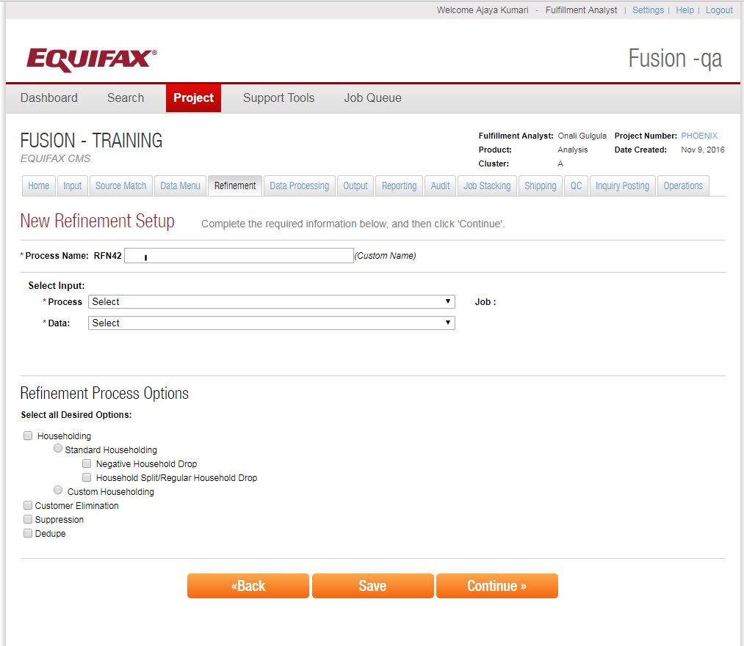

It’s based on the refinement process options that we opt, we get navigated to further screens.

We can refine the data based on house holding (both custom and Standard options are available) for identifying different individuals belonging to the same house hold. Here, we will use House holding key which usually a 25byte key which may comprising of fields like last name, zip code address etc. .

Negative house holding means if any one of the member in the house hold have lower credit score we will not consider other members in the same household.

## Householding Key Configuration

Here, we can configure the household key. Mostly the Fulfillment Analyst will go with standard key.

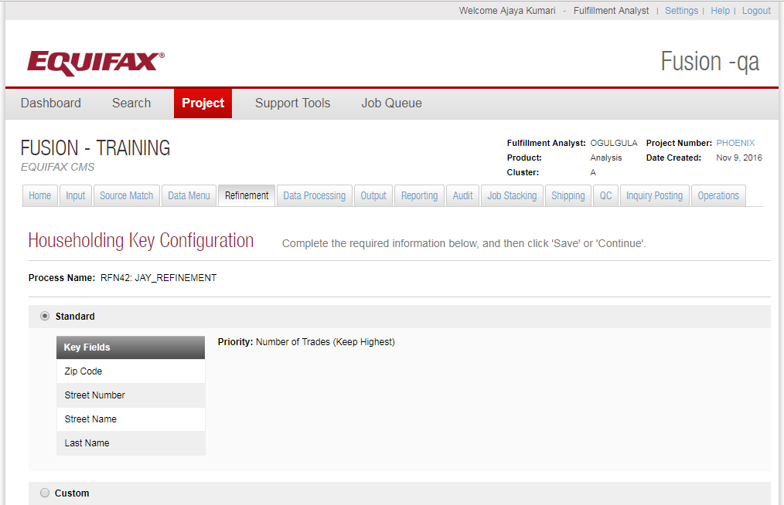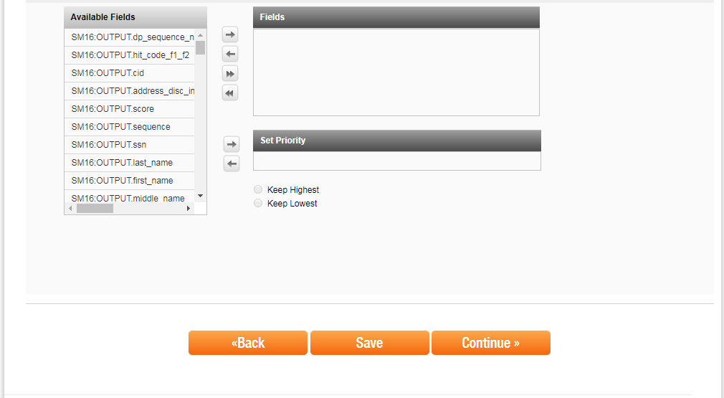

## Householding: Negative Household Drop

If we select negative house holding : it means all of the members from the house hold will be rejected or tagged or drop from/for further process if any one person from the house hold meet the criteria, Persons will be identified based on the House hold key.

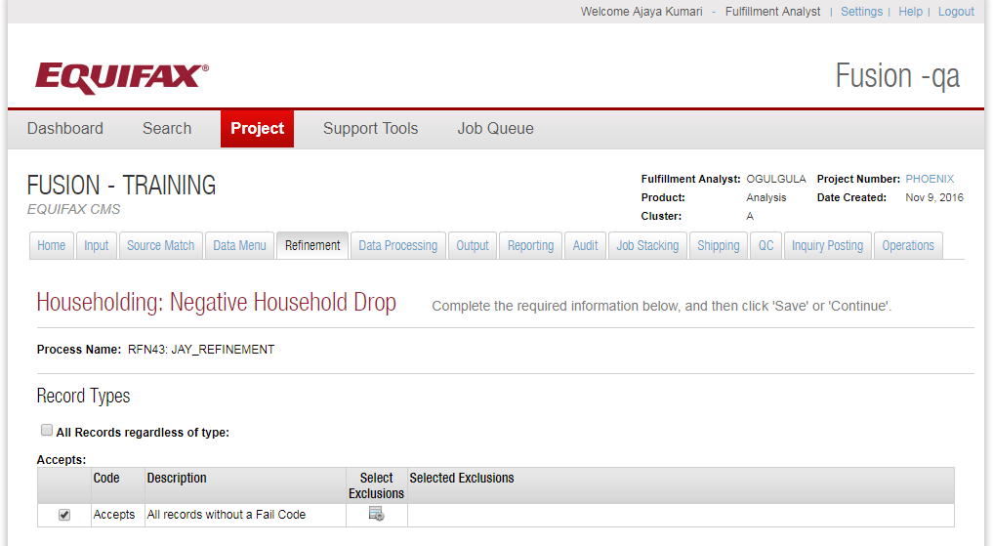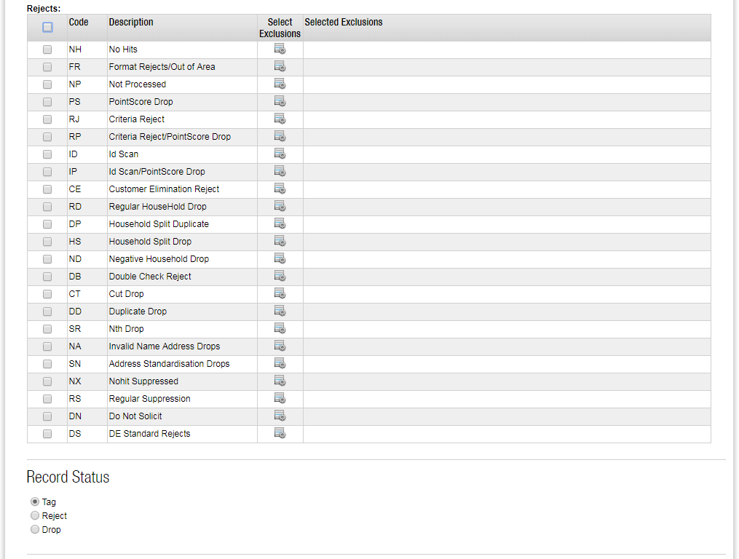

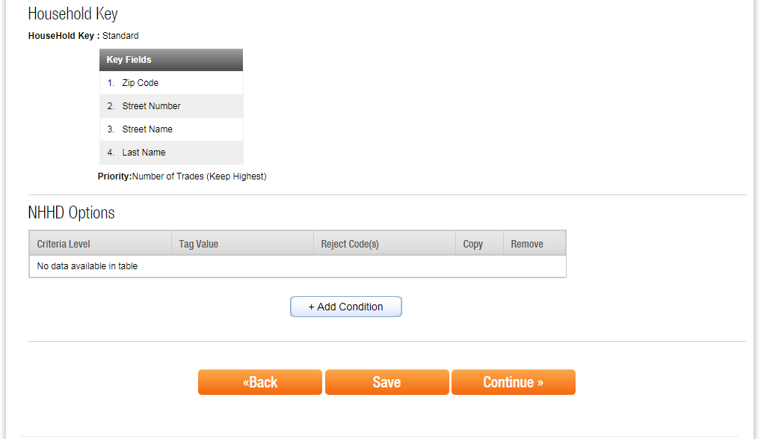

## Household

Similarly with House Holding split means, only one person with highest credit score from the house hold with choose and all other will be tagged or rejected or dropped from dataset.

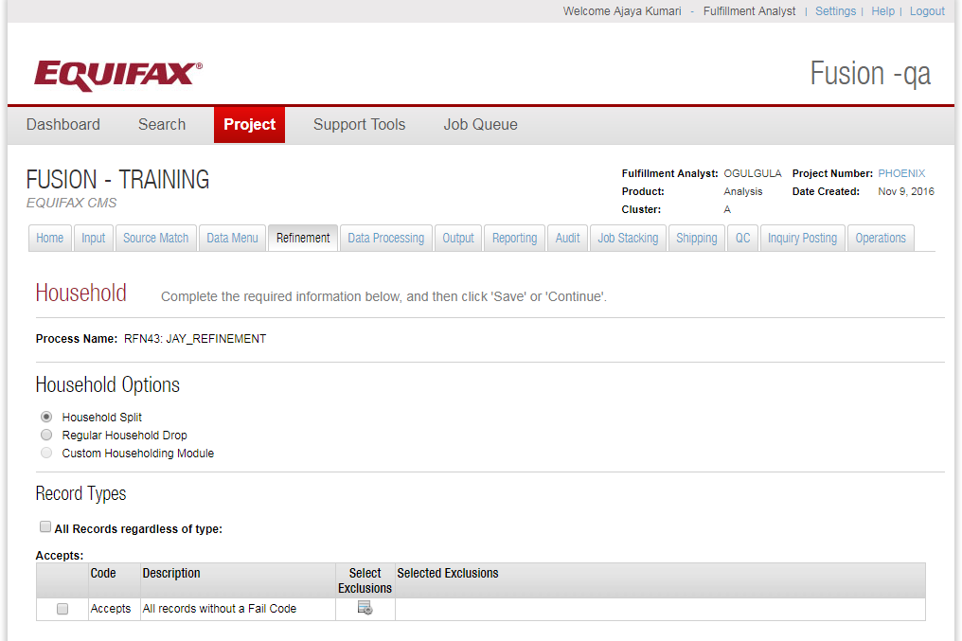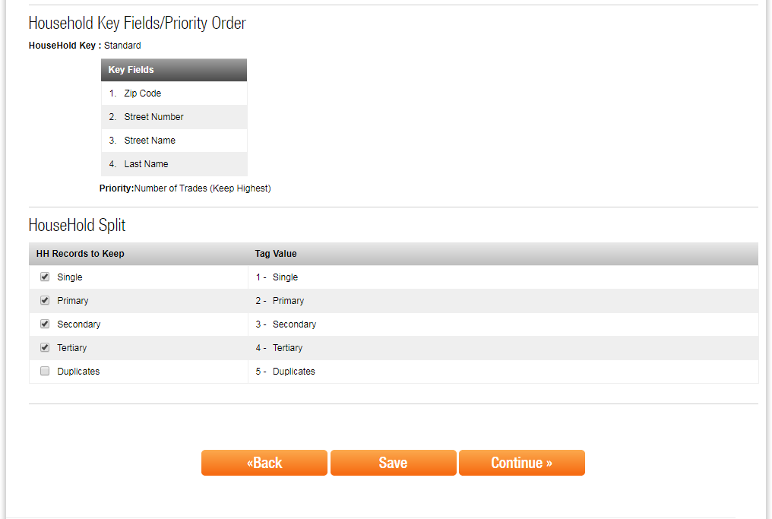

### Record Status

Explain what to be done on the records which were failed in the auto pilot criteria.

* **Tag** – Tag the rejected records and continue process.
* **Reject** – Keep the records but don’t process the rejected records further.
* **Drop** – Remove the rejected records and do not process further on those records. Default selected.

### Record to Process

* This section defines the type of records to process from the selected input, such that the filtering of unwanted record is done. The filtering options available are the Accepts, Rejects and All Records as per the options mentioned in the below screenshot.

These options will available with all post processing.

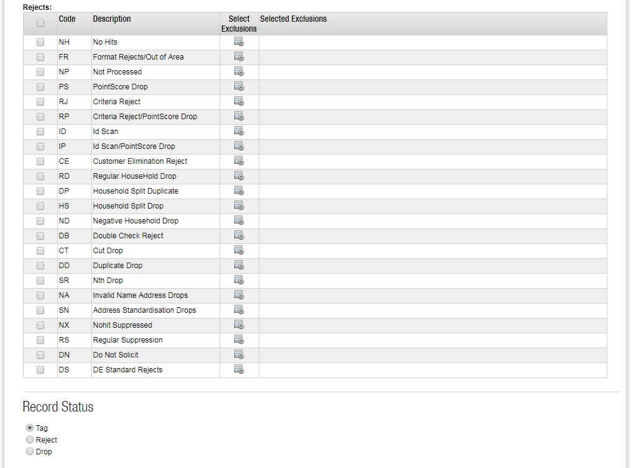

## Customer Elimination Options

Here the customers will be eliminated (Tagged/ dropped, Rejected) at house hold level if they are included in the elimination list or the record is considered for any of the previous execution of the Job.

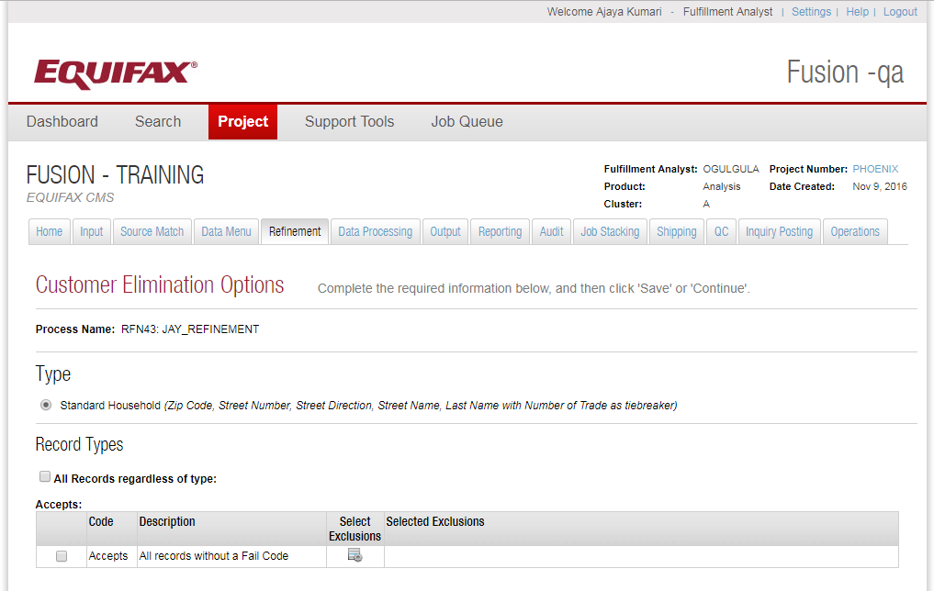 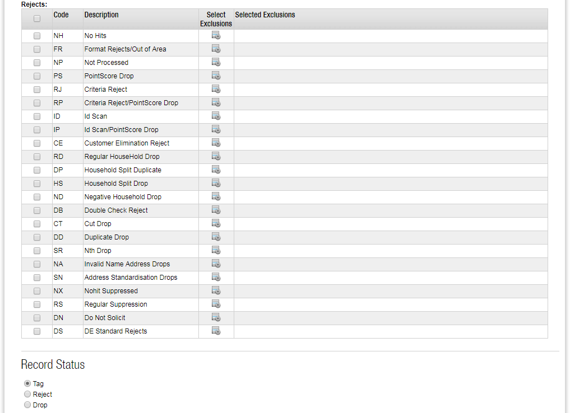 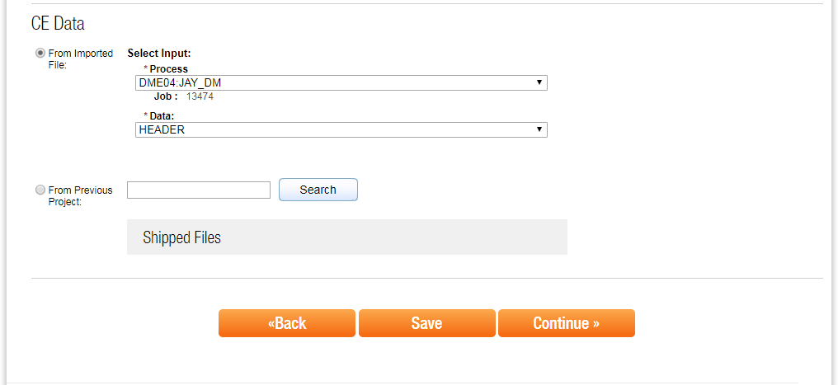

## Suppression Options

Here the customers will be eliminated (Tagged/ dropped, Rejected) at customer level based on CID, SSN or custom if they are included in the elimination list or the record is considered for any of the previous execution of the Job.

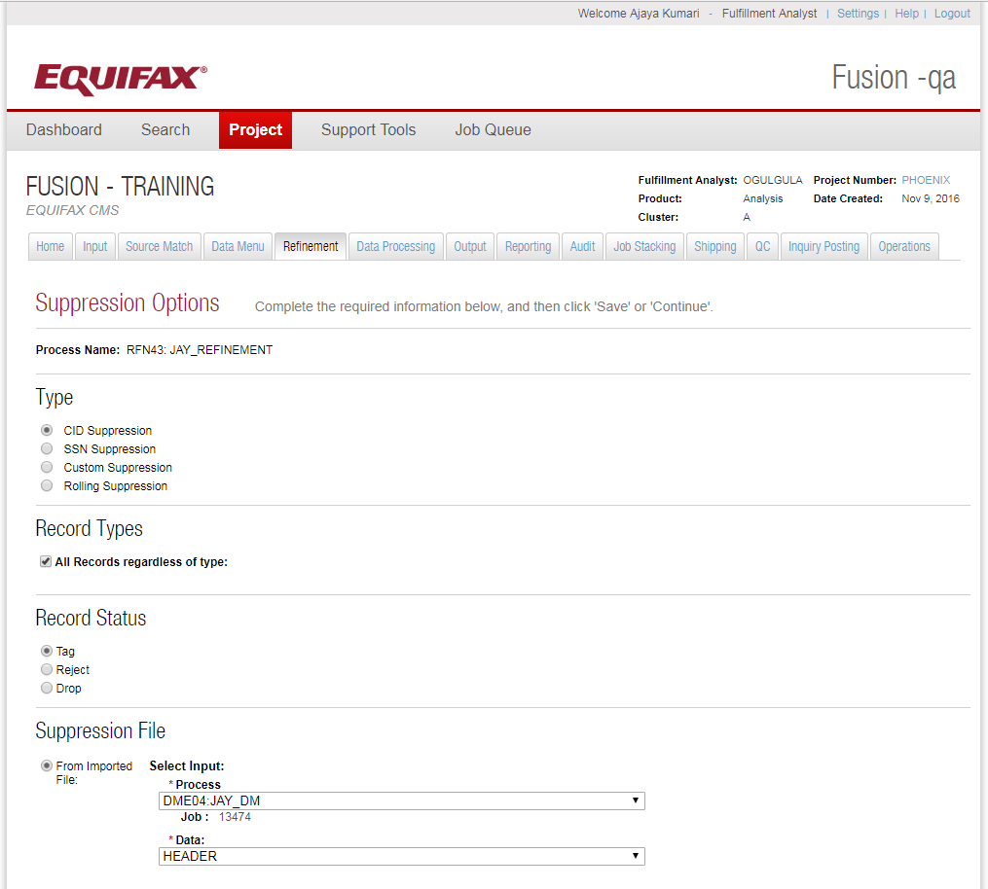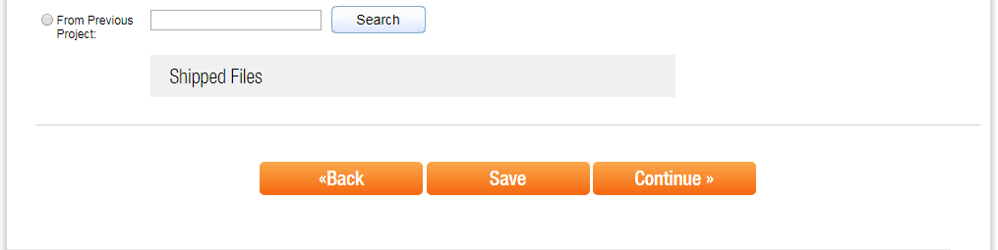

## Dedupe Options

Dedupe option will avoid (Tagged/ dropped, Rejected) duplicate record having same CID, SSN or custom fields

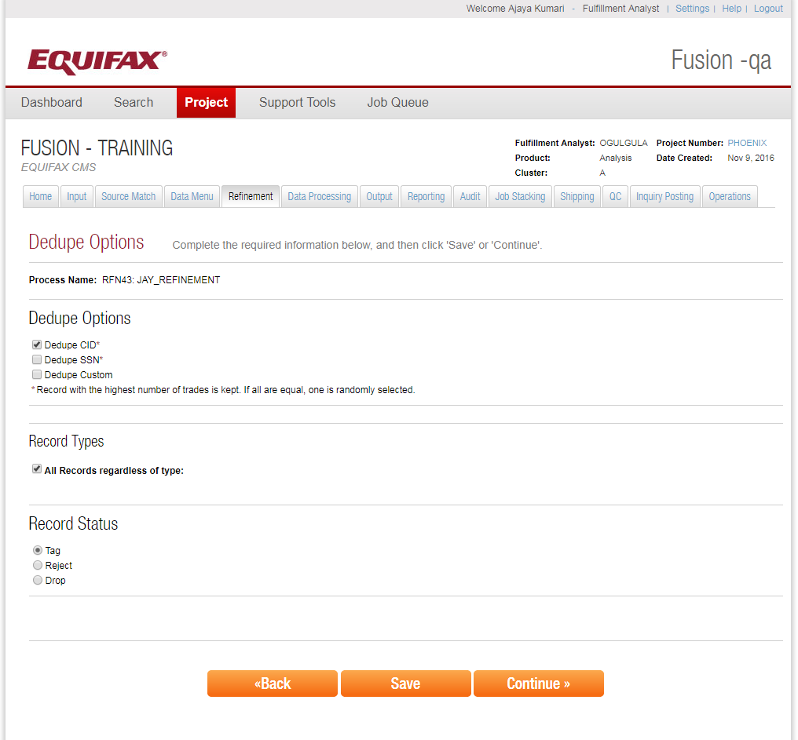

## Summary: Refinement

This page is to review the summary of configuration that we had made.

